**Order Types:** The Order Types tab contains the list of eligible order types you can use to order parts from CNH.

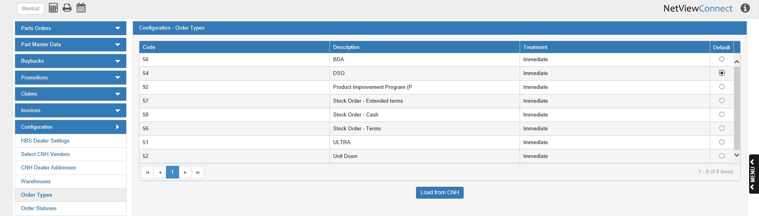

**Load from CNH:** When you first open CNH Connect (CSPS), you must click the **Load from CNH** button at the bottom of the screen to load the order types list, or you will not have access to the types when sending your orders to CNH. As they are a required part of the ordering process, you **absolutely must** load this list when you begin. After that point, the list will automatically reload every 30 days, though you may click the button at any point to reload the most updated list.

**Column Definitions:**

Code: This column shows the CNH Order Type Code.

Description: This column shows the type’s description, which explains what kind of order the type represents (BDA, Unit Down, DSO, etc.).

Treatment: This column shows the order type’s treatment, which is the speed at which the order type is typically processed. The options in this column are “Immediate” or “Deferred,” but for U.S. CNH dealers this column will always say “Immediate,” as there is no deferred processing in the U.S.

Default: Aside from simply containing the list, this tab allows you to set a default order type when creating new orders. Mark the circle in this column for the order type you want, and the system will automatically use it as the default. Note that the program will not let you mark two circles at once; you cannot have more than one default order type.